PARKING SLOT FINDER & BOOKER
@CREATIVITY THINK (9483175986/7019689991)

ABSTRACT:
Parking Slot Finder & Booker is a web-based system designed to help users locate, book, and manage parking slots efficiently in apartments, offices, malls, and event venues. The platform provides real-time slot availability, booking confirmations, check-in/check-out functionality, and usage analytics. Users can register their vehicles, reserve slots for specific dates and times, and track parking history. Administrators can manage parking zones and slots, define booking rules, monitor occupancy, handle disputes, and analyze parking trends via dashboards. Built using Django and Django REST Framework for backend operations, and React with react-calendar and axios for frontend interaction, the system ensures convenience, accuracy, and operational efficiency..

INTRODUCTION OF THE PROJECT:
Urban areas and large facilities often face challenges in managing parking spaces, leading to inefficiencies, disputes, and congestion. Traditional methods of manual booking or first-come-first-serve parking are inefficient and lack transparency. Parking Slot Finder & Booker addresses these problems by providing a centralized, real-time platform for slot discovery, booking, check-in/check-out, and analytics. Users and administrators can efficiently manage parking resources, improve occupancy utilization, and reduce operational conflicts..

PROJECT OBJECTIVES:

• Provide a real-time platform to search and book parking slots
• Enable users to register vehicles and track parking history
• Offer check-in and check-out functionalities for booked slots
• Allow administrators to define zones, slots, and booking rules
• Monitor real-time occupancy and manage disputes or overstays
• Provide analytics dashboards for usage trends and patterns
• Enable exporting of logs and monthly reports
• Ensure secure, scalable backend API handling
• Enhance convenience for users and operational efficiency for administrators

PROBLEM OF THE STATEMENT:
Parking management in multi-occupancy areas is often manual, disorganized, or inefficient, causing confusion, overbooking, and disputes. Without real-time updates and analytics, administrators cannot optimize slot allocation or monitor usage. This system addresses these challenges by providing a digital solution for users to find and book slots easily while giving administrators tools to monitor occupancy, enforce booking rules, and generate usage insights..

MOTIVATION OF THE PROJECT:
• To reduce parking-related stress for users
• To provide real-time availability and booking confirmation
• To minimize disputes and overstays through monitoring
• To improve parking space utilization and efficiency
• To allow administrators to make data-driven decisions via dashboards
• To provide a seamless and intuitive user experience
• To reduce manual processes in parking management
• To support analytics-based operational improvements

BLOCK DAIGRAM OF PROJECT:

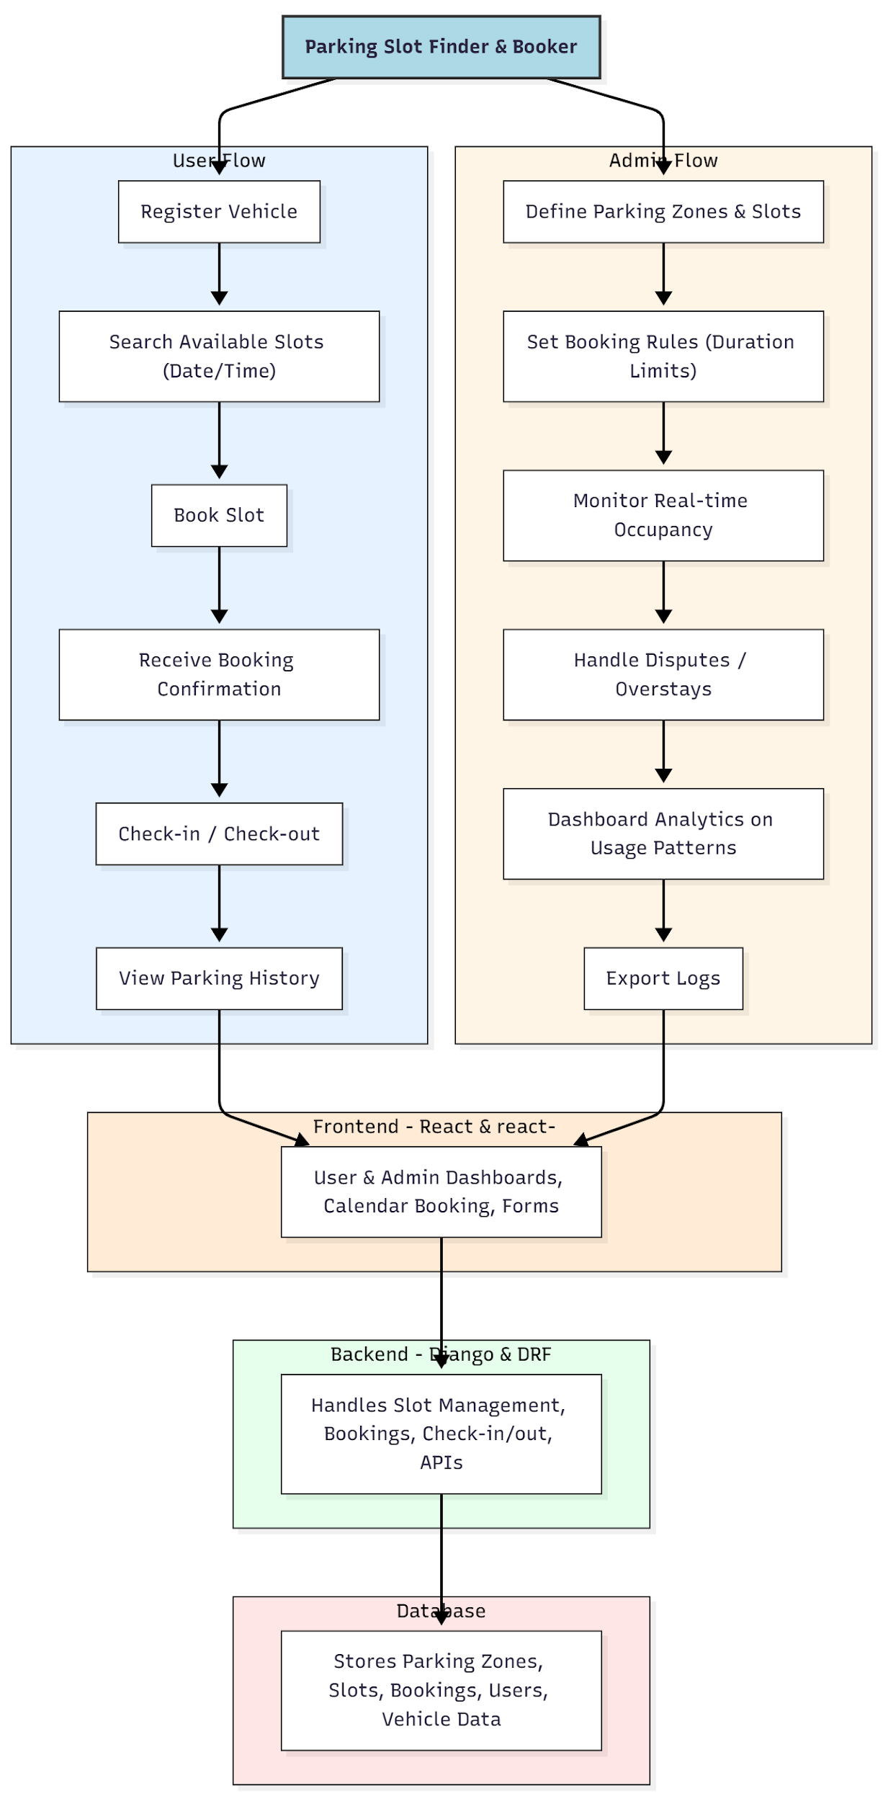

WORKING OF THE PROJECT:
Users start by registering their vehicles and searching for available parking slots for a specific date and time. They can book slots and receive confirmation immediately. Check-in and check-out buttons enable real-time tracking of occupancy. Users can review their parking history at any time.
Administrators define parking zones and slots, enforce booking rules, and monitor real-time occupancy to handle disputes or overstays. Dashboard charts provide analytics on usage patterns, helping optimize parking allocation. The backend manages all API calls, bookings, slot data, and check-in/out statuses, while the database stores structured records to support analytics and reporting..

SOFTWARE REQUIREMENT:
- Backend:
  - Python 3.x
  - Django
  - Django REST Framework
  - SQLite/PostgreSQL
- Frontend:
  - Node.js and npm
  - React.js
  - Axios
- Development Tools:
  - Visual Studio Code
  - Postman (for testing APIs)
  - Git/GitHub (for version control)
- Server/Deployment (Optional):
  - Gunicorn, Nginx, or Heroku/AWS for hosting

ADVANTAGES OF THE PROJECT:

• Provides real-time parking slot availability and booking
• Reduces disputes and overbooking through monitoring
• Streamlines check-in and check-out processes
• Tracks parking history for users
• Allows administrators to optimize slot usage
• Generates dashboards and analytics for decision-making
• Supports export of logs and reports
• Scalable for apartments, offices, malls, and event venues

APPLICATIONS OF THE PROJECT:
• Apartment complexes
• Office parking management
• Mall and shopping center parking
• Event venue parking
• Any organized parking facility

REFERENCES:

- Django REST Framework Documentation — Django Software Foundation. Django Documentation. Available: https://docs.djangoproject.com/
- Django REST Framework. DRF Documentation. Available: https://www.django-rest-framework.org/
- React. React Official Documentation. Available: https://reactjs.org/docs/getting-started.html
- Redux. Redux Documentation. Available: https://redux.js.org/introduction/getting-started
- PostgreSQL Global Development Group. PostgreSQL Documentation. Available: https://www.postgresql.org/docs/
- MySQL. MySQL Reference Manual. Available: https://dev.mysql.com/doc/
- Git. Git Documentation. Available: https://git-scm.com/doc
- Node.js. Node.js Documentation. Available: https://nodejs.org/en/docs/
- Axios. Axios Documentation. Available: https://axios-http.com/docs/intro
- Socket.io Documentation – https://socket.io/docs/

